**Exercise 5: Return Data from a Stored Procedure**

Goal: Create a stored procedure that returns the total number of employees in a

department.

Steps:

1. Define the stored procedure with a parameter for DepartmentID.

2. Write the SQL query to count the number of employees in the specified department.

3. Save the stored procedure by executing the Stored procedure content.

**Output:**

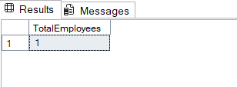

**Code:**

CREATE PROCEDURE sp_CountEmployeesByDepartment

@DepartmentID INT

AS

BEGIN

SELECT COUNT(*) AS TotalEmployees

FROM Employees

WHERE DepartmentID = @DepartmentID;

END;

GO

**Query for Output:**

EXEC sp_CountEmployeesByDepartment @DepartmentID = 2;